|  |  |  |
| --- | --- | --- |
| Product request form | | |
| **Written by** : WOO Dick | **Reviewed by:** HONGKHAM Pauline | Approved by : |
| Last updated date : 02 Jan 2020 |

Product request form through new APP “PR product request”

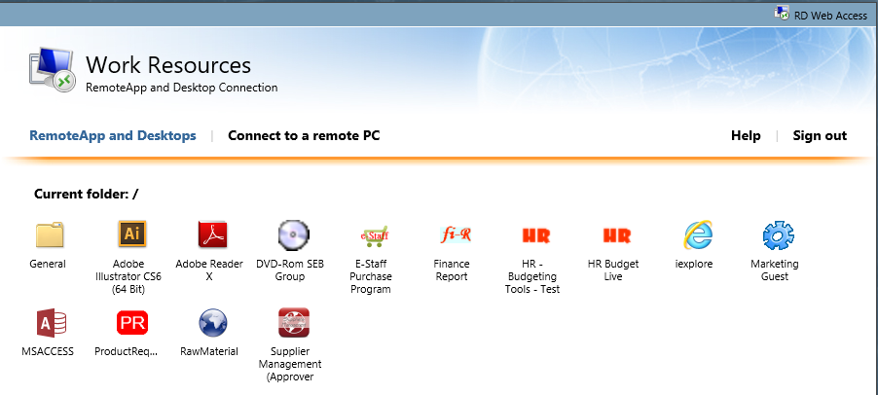

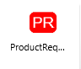

1. **CREATION OF PRODUCT REQUEST IN APP**
2. When you need to send a sample (from our inventory, and which will not be returned) to retailers/ distributor/ Media, open the APP

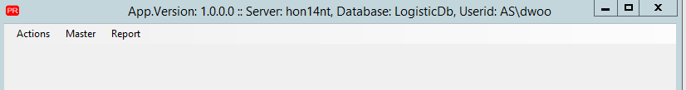

1. Choose “Action”, “Create Product Request”

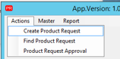

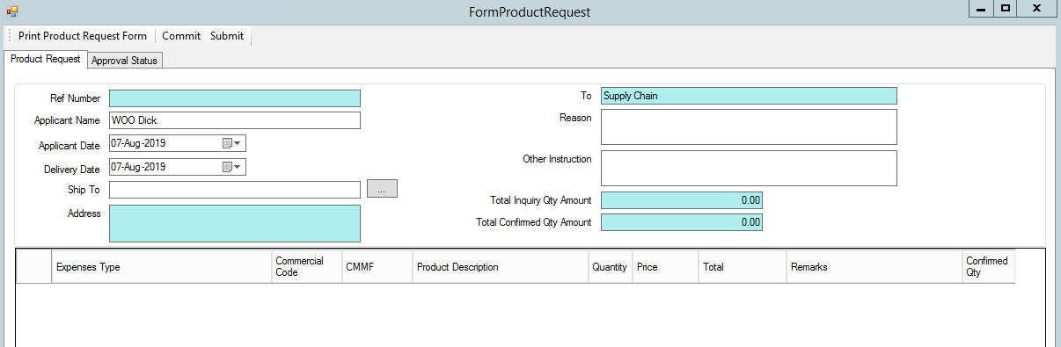

1. Input the necessary information.
   1. Applicant date
   2. Delivery date (= at least applicant date + 3 working days)
   3. Choose “Ship to” (address of delivery, the address must be created in the system before you input the request)
   4. Input Reason
   5. Other Instruction (if any)

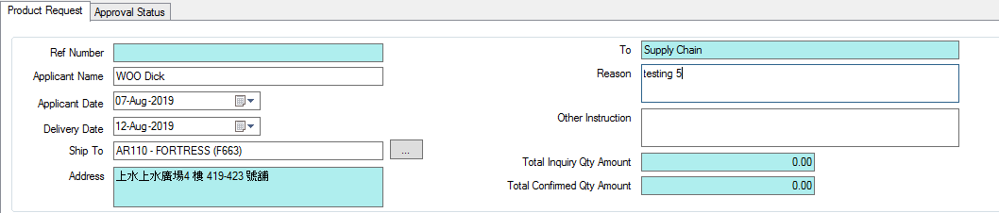

1. Right click at the left corner, choose “Add” to add the item/ CMMF you need



1. Choose the expense type

For Commercial expenses (Sales dept ):

|  |  |
| --- | --- |
| **please choose type of expenses cost center absorbed product cost)** | |
| **Commerical Expense (Sales dept)** | **Account / cost center** |
| Sample Charge (Tefal & Lago) | 627000 37SS70 |
| Sample Charge (WMF) | 627000 37SS73 |

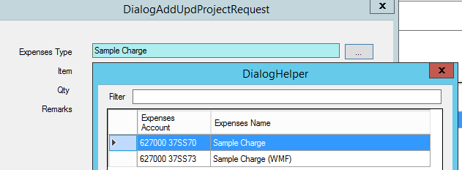

For Marketing expenses (Marketing dept):

|  |  |
| --- | --- |
| **please choose type of expenses cost center absorbed product cost)** |  |
| **Marketing Expense (Marketing dept)** | **Account / cost center** |
| Sample Charge (Tefal & Lago) | 660100-37MK70 |
| Sample Charge (WMF) | 660100-37MK73 |
| Demonstration expenses (Tefal & Lago) | 670000 37DO70 |
| Demonstration expenses (WMF) | 670000 37DO73 |
| Other COS - Free Gifts, GWP (Tefal & Lago) | 660600 37OC70 |
| Other COS - Free Gifts, GWP (WMF) | 660600 37OC73 |

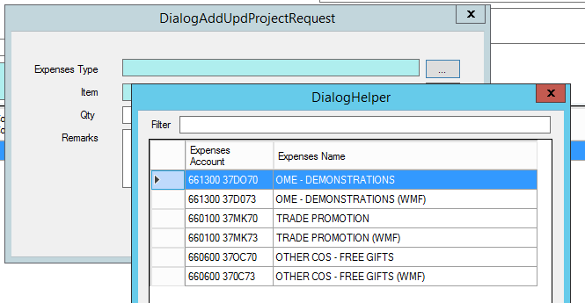*Details please check appendix 1*

1. Choose the CMMF you needed, for WMF items, it should be start with “3201xxxxxx”

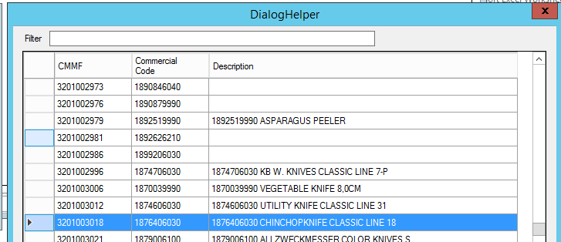

1. Input the quantity
2. Input the remarks/reasons (**MUST be input**): eg.“ sample to KOL”, “sample for demonstration”, GWP,…etc

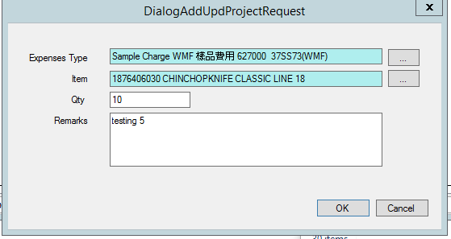

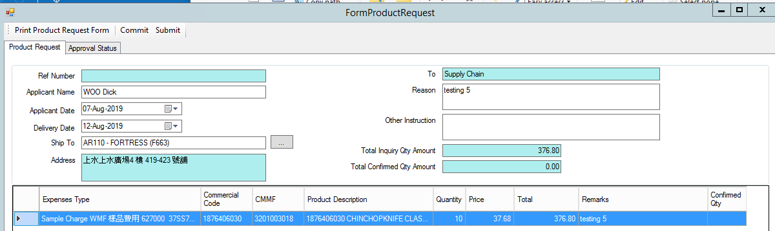

1. After input all the CMMFs you want, the total cost (for reference) will be calculated.
2. If ok, you can “Submit”

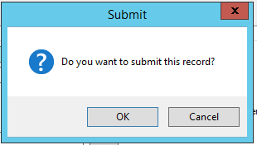

1. If the form is still not yet finished, you can choose “Commit”

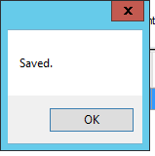, then you can update it later.

1. When you commit or submit, an auto reference number will be generated.

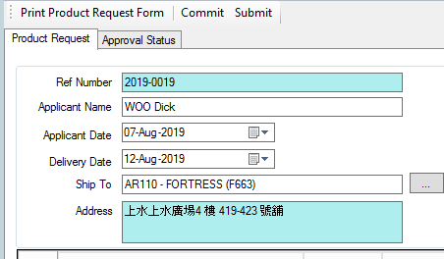

1. After you submit the request, the N+1 Manager will receive any email to remind he/she to approve your request (if the total amount of sample/product request is over HKD10K, further approval by Jo SHUM (MD) is needed)

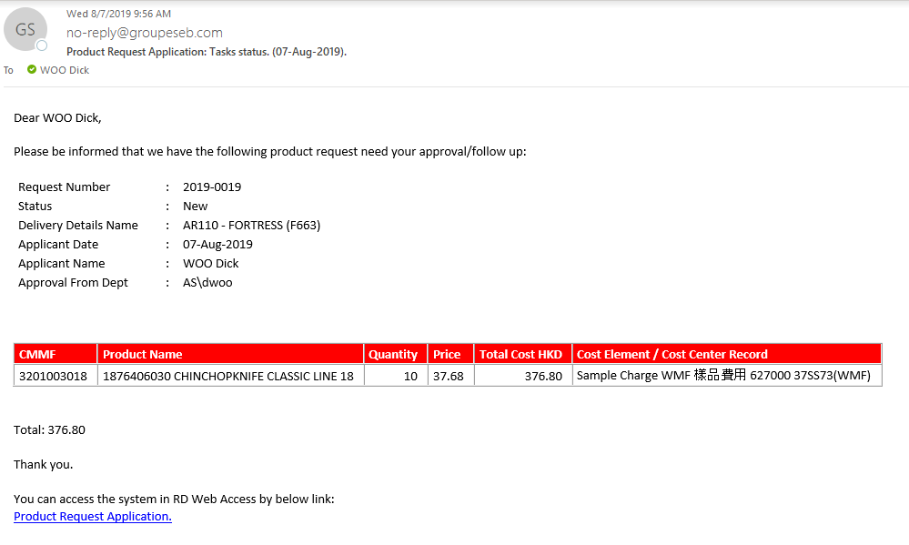

1. When the Manager is approved the request, email will be sent to “Supply Chain” (Christine CHU and Reiko LEUNG).
2. The final quantity available in stock will be checked by supply chain, if the quantity is not enough, they can adjust the final quantity before delivery.

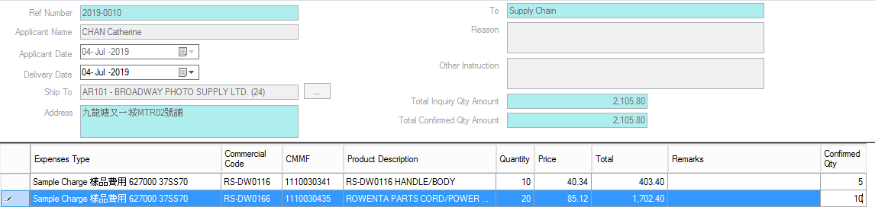

1. On the other hand, if you request is “**REJECTED**” by the Manager, you will also receive an email.

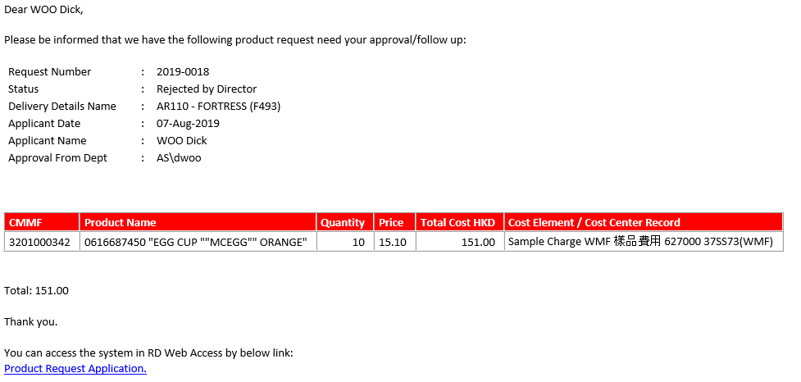

1. **APPROVE THE PRODUCT REQUEST IN APP**
2. When Manager received the request by email, he/she may lock in to the APP (Selling – Boris TAM, Marketing – Michael YU)
3. Choose: Action > product Request approval

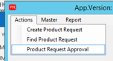

1. In “My Tasks”, you should find the “New” request

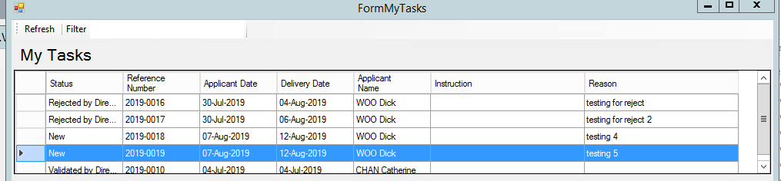

1. Double click to open,

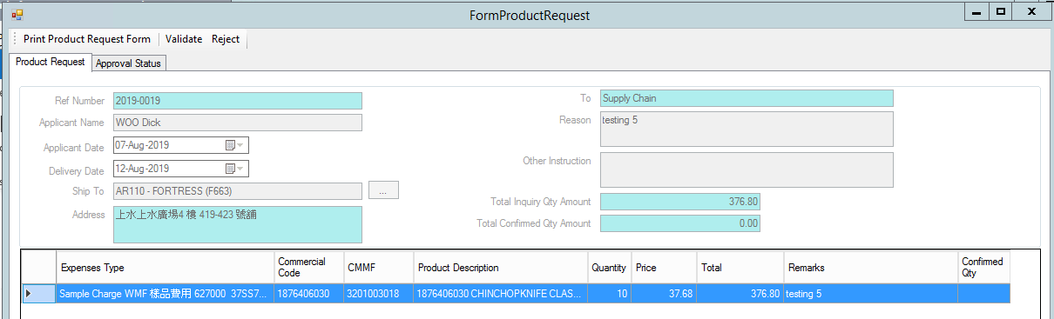

1. If the request is ok, you can choose “Validate”

Appendix

1. How to choose the type of examples:

|  |  |  |  |
| --- | --- | --- | --- |
| **COMMERCIAL EXPENSES (T8003)** | |  | **Purpose or example:** |
| Selling expenses (800301) | |  |  |
| 800301 | **627000-37SS70** | **SAMPLE CHARGES** | **products to retailers /distributor for promoting purpose – Tefal / Lago products** |
| 800301 | **627000-37SS73** | **SAMPLE CHARGES WMF** | **products to retailers /distributor for promoting purpose – WMF products** |
|  |  |  |  |
| **OPERATIONAL MARKETING DIRECT EXPENSES (T80040)** | | |  |
| Demonstration expenses (800302) | |  |  |
| 800302 | **661300-37DO70** | **OME - DEMONSTRATIONS** | **products used for demonstration purposes for internal use or at retailers – Tefal / Lago products** |
| 800302 | **661300-37DO73** | **OME – DEMONSTRATIONS WMF** | **products used for demonstration purposes for internal use or at retailers – WMF products** |
|  |  |  |  |
| Trade marketing expenses (800401) | |  |  |
| 800401 | **660100-37MK70** | **TRADE PROMOTION** | **products to KOL or for marketing purpose, sponsorship of an event..etc – Tefal / Lago products** |
| 800401 | **660100-37MK73** | **TRADE PROMOTION WMF** | **products to KOL or for marketing purpose, sponsorship of an event..etc – WMF products** |
|  |  |  |  |
| **Other cost of sales - commercial (T7403)** | |  |  |
| Commercial costs on products (730302) | |  |  |
| 730302 | **660600-37OC70** | **OTHER COS - FREE GIFTS** | **GWP (Gift With Purchase) – Tefal / Lago products** |
| 730302 | **660600-37OC73** | **OTHER COS - FREE GIFTS (WMF)** | **GWP (Gift With Purchase) – WMF products** |